PROJECT REPORT

LegalEase
AI Powered Legal Document Generator
Design, Implementation and Evaluation of a Web-Based Platform for Simplified Legal Document Creation

Project Title | LegalEase - AI Powered Legal Document Generator
Project Type | Web Application
Technologies | HTML5, CSS3, JavaScript
Document Types | Rental Agreement, NDA, Employment Agreement, Affidavit, Legal Notice

Table of Contents
1. Executive Summary 1
2. Introduction 2
3. Need Analysis and Related Work 3
4. Project Overview 4
5. Requirement Analysis 5
6. System Design 6
7. Implementation 8
8. Testing and Validation 10
9. Results and Discussion 11
10. Security, Privacy and Legal Considerations 12
11. Limitations 13
12. Future Enhancements 14
13. Conclusion 15
14. References 16
Appendix A: Glossary 17
Appendix B: Sample Output 18

1. Executive Summary
LegalEase is a web-based application that helps everyday users begin the process of preparing common legal documents. Legal paperwork is often expensive, intimidating and full of specialised vocabulary. LegalEase addresses this by presenting a single, clean form in which a user chooses the type of document they need, enters their name and describes the details in plain language. The application then assembles this information into a structured document preview on the same page.
The current release is a lightweight front-end prototype built with HTML5, CSS3 and vanilla JavaScript. It runs entirely in the browser with no server, database or installation, which makes it fast, portable and easy to demonstrate. It supports five document categories: Rental Agreement, Non-Disclosure Agreement, Employment Agreement, Affidavit and Legal Notice.
The platform is branded as an AI powered generator because its architecture is designed to accept an artificial-intelligence language model as its drafting engine. In the present prototype, the generation step performs input validation and structured presentation of the user's data; connecting the interface to an AI drafting service is the principal item on the roadmap described in Chapter 12.
Key Highlights
Single-page interface | Five supported document types | Client-side validation | Responsive layout | No installation or backend required | Extensible architecture for AI, PDF export and user accounts

1.1 Purpose of this Report
This report documents the motivation, requirements, design, implementation and evaluation of LegalEase. It also records the limitations of the current build, the security and legal considerations that apply to software of this kind, and a phased plan for future development. It is intended for academic reviewers, project mentors, prospective contributors and anyone evaluating the project.

2. Introduction

2.1 Background
Almost every adult encounters legal documents at some point: a landlord and tenant sign a rental agreement, a startup asks contractors to sign a non-disclosure agreement, an employer issues an employment contract, a citizen submits an affidavit to a public office, or a business sends a legal notice to recover dues.
Professional drafting is reliable but costly and slow for routine needs, while free templates are generic and often outdated. A guided tool that collects the essential facts and produces a well-organised draft can close this gap, leaving complex matters to qualified lawyers.

2.2 Problem Statement
Ordinary users lack a simple way to prepare the first draft of a routine legal document. Existing options assume legal knowledge, demand registration before showing value, or present long, confusing forms. A fast, plain-language tool is needed to guide users from intent to a structured draft in a few steps.

2.3 Objectives
- Provide one unified interface for creating several categories of legal documents.
- Reduce the effort of starting a legal document to three inputs: type, name and details.
- Validate user input before generation so incomplete requests are caught early.
- Deliver a professional, accessible and mobile-friendly visual design.
- Establish a modular foundation that can later integrate AI drafting, export and storage.

2.4 Scope
In scope: the single-page web interface, document-type selection, input capture, client-side validation, on-screen display of the generated document summary, and documentation of the design and roadmap.
Out of scope for this release: user authentication, persistent storage, e-signatures, PDF/DOCX export, jurisdiction-specific clause libraries, payment processing, and live integration with an AI language model.

2.5 Intended Audience
Audience | Interest in LegalEase
Individuals and tenants | Quickly start a rental agreement, affidavit or notice.
Freelancers and businesses | Prepare NDAs and employment paperwork with minimal cost.
Students and reviewers | Study a complete example of a small, well-structured web application.
Developers | Extend the prototype with AI, export and back-end features.

3. Need Analysis and Related Work

3.1 The Access-to-Legal-Help Gap
Legal services are unevenly accessible. For many individuals and small organisations, the cost, time and jargon involved in routine legal paperwork act as barriers. Simple tasks such as documenting a tenancy or protecting confidential business information are frequently done informally or not at all, which exposes people to avoidable disputes. Digital tools that standardise routine drafting can reduce this exposure.

3.2 Existing Approaches
Approach | Strengths | Weaknesses
Hiring a lawyer | Accurate, tailored, legally accountable. | Expensive and slow for routine, low-risk documents.
Downloadable static templates | Free and immediately available. | Generic, often outdated, easy to fill in incorrectly.
Online document-assembly platforms | Guided questionnaires and export options. | Often require sign-up or payment; interfaces can be dense.
General-purpose AI chat tools | Flexible and conversational. | No structured workflow; output consistency depends on the prompt.
Table 3.1: Comparison of common approaches to obtaining legal documents

3.3 Positioning of LegalEase
LegalEase sits between static templates and full document-assembly suites. It keeps the interaction deliberately small (three inputs on one screen) so that a first-time user can see value within seconds. Because it is delivered as a single web page, it can be hosted anywhere, embedded in another site, or used offline once downloaded.

3.4 Identified Needs
- Simplicity: a short form in plain language with clear labels.
- Speed: results appear instantly, with no page reload.
- Trust: a professional appearance and transparent limitations.
- Accessibility: works on phones, tablets and desktops without installation.
- Extensibility: ability to add document types and smarter drafting over time.

4. Project Overview

4.1 About LegalEase
LegalEase is presented as a single web page with three regions: a dark header carrying the product name and tagline, a central card containing the document form, and a footer with copyright information. The design uses a neutral grey page background, a white content card with a soft shadow, and a strong blue call-to-action button, giving the product a clean, trustworthy appearance suitable for a legal-technology service.

4.2 Key Features
Feature | Description
Document type selector | Drop-down list of five legal document categories with a clear placeholder option.
Name capture | Single-line text field for the person creating the document.
Free-text details | Resizable multi-line field where the user describes the facts, parties, dates and terms.
One-click generation | A prominent button that validates input and renders the result immediately.
Instant result panel | A bordered panel that appears below the form showing the document type, name and details.
Input validation | Alerts the user if the document type or name is missing.
Responsive layout | Fluid width with a maximum container size, suitable for mobile and desktop screens.
Table 4.1: Feature summary

4.3 Supported Document Types
Document Type | Typical Purpose | Suggested Details to Provide
Rental Agreement | Records the terms under which a property is let by a landlord to a tenant. | Parties, property address, monthly rent, deposit, tenure, notice period.
Non-Disclosure Agreement | Protects confidential information shared between parties. | Parties, nature of information, duration, permitted use, exclusions.
Employment Agreement | Sets out the relationship between employer and employee. | Job title, salary, start date, probation, working hours, termination terms.
Affidavit | A written statement of facts made on oath or affirmation. | Deponent details, facts being declared, purpose, submitting authority.
Legal Notice | A formal written communication asserting rights or demanding action. | Sender, recipient, cause of action, relief sought, time allowed to comply.
Table 4.2: Document types available in LegalEase

5. Requirement Analysis

5.1 Functional Requirements
ID | Requirement | Priority
FR-01 | The system shall let the user choose one document type from a predefined list. | High
FR-02 | The system shall accept the user's name as text input. | High
FR-03 | The system shall accept free-text document details in a multi-line field. | High
FR-04 | The system shall reject generation when no document type is selected and inform the user. | High
FR-05 | The system shall reject generation when the name is empty or only whitespace and inform the user. | High
FR-06 | The system shall display the selected document type, name and details in a result panel on demand. | High
FR-07 | The system shall show a default message when no details are provided. | Medium
Table 5.1: Functional requirements

5.2 Non-Functional Requirements
Category | Requirement
Usability | A first-time user should be able to generate a document without instructions.
Performance | Generation should feel instantaneous because all processing is local to the browser.
Compatibility | Should work on current versions of Chrome, Edge, Firefox and Safari, and on mobile browsers.
Maintainability | Clear separation of structure (HTML), presentation (CSS) and behaviour (JavaScript).
Accessibility | Labelled form controls, sufficient colour contrast and keyboard operability.
Table 5.2: Non-functional requirements

5.3 Hardware and Software Requirements
Item | Minimum Requirement
Device and OS | Any phone, tablet, laptop or desktop running Windows, macOS, Linux, Android or iOS
Browser | Any current release of Chrome, Edge, Firefox or Safari with JavaScript enabled
Development tools | Any text editor (for example VS Code) and a web browser for testing
Table 5.3: Environment requirements

6. System Design

6.1 Architectural Overview
LegalEase follows a simple layered design. The presentation layer (HTML and CSS) renders the header, input form and result panel. The logic layer (JavaScript) validates inputs, maps the selected document type to a readable name and renders the output into the page. A services layer, shown with dashed outlines in Figure 6.1, is reserved for planned capabilities such as an AI drafting engine, file export and user storage.
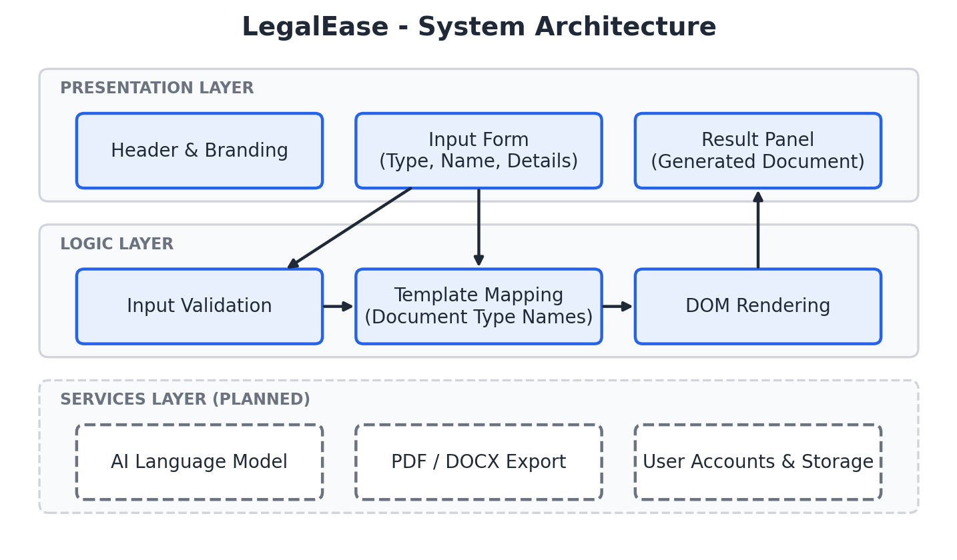
Figure 6.1: Layered architecture of LegalEase

6.2 Workflow
The user journey is linear and short. After opening the page, the user selects a document type, provides a name and optional details, and presses the generate button. The system checks the inputs. If validation fails, an alert explains what is missing; if it passes, the document is assembled and displayed in the result panel.
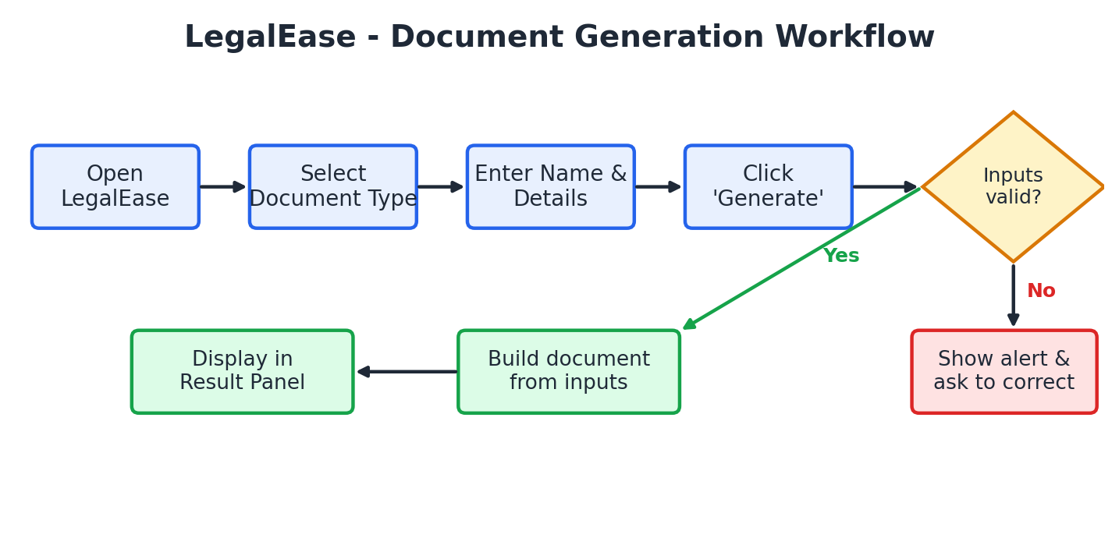
Figure 6.2: End-to-end document generation workflow

6.3 User Interface Design
UI Component | Purpose | Design Notes
Header banner | Brand identity and tagline | Dark slate background, white text, centred title at 36 px
Form card | Holds all inputs | White card, 12 px rounded corners, soft shadow, 800 px maximum width
Document Type select | Choose document category | Full-width drop-down with placeholder option
Name input | Capture the user's name | Full-width text box with placeholder
Details textarea | Capture facts and terms | Minimum height 120 px, vertically resizable
Generate button | Primary call to action | Full-width blue button with bold label
Result panel | Show generated document | Hidden by default; light grey box with border
Footer | Copyright line | Centred grey text
Table 6.1: User interface components

6.4 Visual Design System
Element | Value | Usage
Primary blue | #2563EB | Call-to-action button
Dark slate | #1F2937 | Header background
Page background | #F4F6F8 | Overall page canvas
Card background | #FFFFFF | Form container
Typeface | Arial | All text
Table 6.2: Colour palette and typography

7. Implementation

7.1 Technology Stack
Technology | Role in the Project
HTML5 | Semantic structure: header, form controls, result container and footer.
CSS3 | Layout, colour, spacing, rounded corners, shadows and responsive behaviour.
JavaScript (ES6) | Event handling, validation, mapping and dynamic DOM updates.
Table 7.1: Technologies used

7.2 Page Structure
The document is a single HTML file. The <head> declares UTF-8 encoding, a responsive viewport and an embedded stylesheet. The <body> contains a header, a central container with the form and result area, a footer, and an inline script. Each input has a matching <label> linked by its for attribute, which improves accessibility and makes the touch target larger on mobile devices.

7.3 Styling
A universal box-sizing: border-box rule keeps element sizing predictable. The container is centred with margin: 40px auto and limited to 800 px width, so it scales down gracefully on small screens. Inputs, the select box and the textarea share full-width styling with 12 px padding, a light border and rounded corners for visual consistency. The result panel is hidden with display: none and revealed by JavaScript when needed.

7.4 Core Logic
All behaviour is implemented in one function, generateDocument(), triggered by the button's click handler. It reads the three field values, validates them, translates the internal type code into a human-readable name, builds an HTML string and inserts it into the result paragraph before making the panel visible.
function generateDocument() {
const t = document.getElementById("documentType").value,
n = document.getElementById("name").value,
d = document.getElementById("details").value;

if (!t) { alert("Please select a document type."); return; }
if (!n.trim()) { alert("Please enter your name."); return; }

const names = {
rental: "Rental Agreement",
nda: "Non-Disclosure Agreement",
employment: "Employment Agreement",
affidavit: "Affidavit",
notice: "Legal Notice"
};

document.getElementById("documentOutput").innerHTML =
"<strong>Document Type:</strong> " + names[t] + "<br><br>" +
"<strong>Name:</strong> " + n + "<br><br>" +
"<strong>Details:</strong><br>" + (d || "No additional details provided.");

document.getElementById("result").style.display = "block";
}

Listing 7.1: The generateDocument() function

7.5 Validation Logic
Validation runs before any output is produced. The document type is checked for a non-empty value, so the placeholder option cannot be submitted. The name is passed through trim() so that a field containing only spaces is treated as empty. In both cases the function shows an alert and returns immediately, leaving any previous result untouched.

7.6 Output Rendering
A dictionary object maps short internal codes such as nda to display names such as Non-Disclosure Agreement. This keeps the drop-down values compact while presenting friendly labels in the result. Adding a new document type therefore requires only a new <option> element and one new entry in the dictionary.
Extending the Application
To add a new document type, insert an <option> in the selector, add its code and display name to the names object, and (in future releases) register a template or AI prompt for it.

8. Testing and Validation

8.1 Test Strategy
Testing focused on functional behaviour, input validation, output correctness and interface responsiveness. Test outcomes in this chapter were determined by tracing the logic of the source code against each scenario. Before formal submission or release, the same cases should be re-run manually in the browsers and devices the project targets.

8.2 Functional Test Cases
ID | Scenario | Input | Expected Result | Status
TC-01 | No document type chosen | Type empty, name filled | Alert: select a document type; no output | Pass
TC-02 | Empty name | Type chosen, name empty | Alert: enter your name; no output | Pass
TC-03 | Whitespace-only name | Type chosen, name = spaces | Alert: enter your name; no output | Pass
TC-04 | Valid input, no details | Type + name, details empty | Result shows default 'No additional details' text | Pass
TC-05 | Valid input with details | Type + name + details | Result shows type, name and details | Pass
TC-06 | Each document type | Select every option in turn | Correct display name for all five types | Pass
TC-07 | Regenerate with new data | Change fields, click again | Result panel updates with the new values | Pass
TC-08 | Initial page load | Open page | Result panel hidden | Pass
TC-09 | Long details text | Several paragraphs of text | Text displayed in full within the panel | Pass
TC-10 | Small-screen layout | Viewport below 480 px | Container shrinks; fields remain usable | Pass
Table 8.1: Functional test cases

8.3 Observations from Testing
- Line breaks typed in the details box are not preserved in the result, because plain newlines collapse in HTML unless converted or styled (see Chapter 11).
- User-entered text is inserted with innerHTML, which is a security concern documented in Chapter 10.
- Alerts are functional but interrupt the user; inline error messages would be a smoother experience.

9. Results and Discussion

9.1 Achievement of Objectives
Objective | Outcome
Unified interface for several document types | Achieved. Five document types are available from a single selector.
Minimal effort to start | Achieved. Only three inputs, of which two are required.
Early validation | Achieved. Missing type or name is detected before output.
Professional, responsive design | Achieved. Clean card layout with a consistent colour scheme.
Foundation for AI and export | Partially achieved. Structure is ready; AI and export are not yet integrated.
Table 9.1: Objectives versus outcomes

9.2 Strengths
- Simplicity: the entire experience fits on one screen.
- Zero dependencies: a single HTML file works on any modern device.
- Speed: results appear instantly because no network call is required.
- Clarity of code: small, readable codebase that is easy to extend.

9.3 Discussion
The prototype demonstrates that the core interaction can be made extremely short without sacrificing clarity. Its current output is a structured summary of the user's own inputs, not yet a full legal draft. This is an intentional first milestone: it validates the interface, data model and user flow before investing in the more complex drafting layer. Once an AI engine and clause templates are attached, the same interface will be able to return complete, formatted documents.

10. Security, Privacy and Legal Considerations

10.1 Security Considerations
The most important technical issue in the present code is that the name and details typed by the user are concatenated into a string and assigned to innerHTML. If a user (or an attacker who tricks a user into pasting content) enters HTML or script markup, the browser may interpret it. Because the application is client-side and displays only the current user's own input, the practical risk is limited, but this pattern must be corrected before the tool handles shared, stored or server-provided content.
Risk | Description | Recommended Mitigation
Cross-site scripting (XSS) | User text is inserted as HTML through innerHTML. | Use textContent or escape special characters; build nodes with createElement.
Data exposure | Sensitive personal details may be entered. | Keep processing local; when a server is added, use HTTPS and minimise retention.
Untrusted AI output | Future AI text could contain unexpected markup. | Sanitise all generated content before rendering.
Input abuse | Extremely long inputs could degrade the page. | Apply maximum lengths and clear error messages.
Table 10.1: Security risks and mitigations

10.2 Privacy
In the current build, all data stays in the user's browser and is never transmitted. This is a valuable privacy property and should be preserved wherever possible. When AI services or storage are introduced, the project should publish a clear privacy notice, obtain consent before processing personal data, and align with applicable data-protection law, such as the Digital Personal Data Protection Act, 2023 in India.

10.3 Legal Disclaimer and Responsible Use
Legal documents have real consequences. Requirements differ by country, state and document type; for example, rental agreements may need to be stamped or registered under local law, affidavits are typically sworn or notarised before a competent authority, and legal notices must satisfy procedural rules to be effective. LegalEase is intended as a drafting aid and must not be represented as a substitute for professional legal advice.
Recommended Disclaimer
LegalEase provides general document drafting assistance only. It does not provide legal advice and does not create a lawyer-client relationship. Please have important documents reviewed by a qualified legal professional before signing or filing.

A visible disclaimer, a review prompt before download, and jurisdiction selection are recommended additions to the interface.

11. Limitations
An honest description of limitations helps users and future contributors set correct expectations. The known limitations of the current release are listed below.
Area | Limitation | Impact
AI drafting | No language model is connected; output echoes the user's inputs. | Documents are summaries, not full legal drafts.
Templates | No clause libraries or jurisdiction-specific wording. | Cannot yet guarantee legal completeness.
Export | No PDF or Word download; no print stylesheet. | User must copy text manually.
Formatting | Line breaks in the details field are not preserved. | Multi-paragraph input appears as one block.
Persistence | No accounts or saved history. | Work is lost when the page is refreshed.
Feedback | Errors are shown with browser alerts. | Less polished than inline messages.
Accessibility | No live region announces the result to screen readers. | Reduced experience for assistive-technology users.
Language | Interface is English only. | Limits reach in multilingual regions.
Security | innerHTML used for user content. | Should be replaced with safe rendering.
Table 11.1: Current limitations

12. Future Enhancements
The roadmap below organises planned improvements into phases so that each release delivers visible value while reducing risk.
Phase | Focus | Planned Deliverables
Phase 1: Hardening | Quality and safety | Safe text rendering, preserved line breaks, inline validation messages, visible legal disclaimer, accessibility improvements, print stylesheet.
Phase 2: Real documents | Templates and export | Structured templates with numbered clauses, guided fields per document type, PDF and DOCX export, copy-to-clipboard.
Phase 3: AI drafting | Intelligent generation | Integration with a language model through a secure back end, prompt templates per document type, clause suggestions, plain-language explanations of each clause.
Phase 4: Accounts and storage | Continuity | User sign-in, saved drafts, version history, secure encrypted storage.
Phase 5: Expansion | Reach and trust | Jurisdiction selection, regional-language support, e-signature workflow, lawyer review marketplace, analytics.
Table 12.1: Development roadmap

12.1 Proposed AI Integration Approach
- The browser sends the document type and the user's structured answers to a secure back-end endpoint.
- The back end builds a prompt from a vetted template for that document type and calls the language model.
- The response is checked against a required-clause list and sanitised for safe display.
- The formatted draft is returned to the browser, where the user can edit, review and export it.
- A disclaimer and review prompt are shown before download.

13. Conclusion
LegalEase demonstrates how a focused, well-designed interface can make the first step of legal document creation approachable. Within a single lightweight page, it offers a guided form, immediate validation and instant feedback, wrapped in a professional visual design that reflects the seriousness of its subject.
The current build is best understood as a solid foundation rather than a finished product. It validates the user experience, establishes a clean code structure and identifies the specific improvements needed to become a complete, AI-assisted drafting tool: safer rendering, structured templates, export, real AI integration and clear legal safeguards.
If these steps are followed, LegalEase can grow into a trustworthy assistant that saves people time and money on routine legal paperwork while directing them to professional advice where it matters most.

14. References
- Mozilla Developer Network (MDN). HTML, CSS and JavaScript documentation. developer.mozilla.org
- World Wide Web Consortium (W3C). HTML Living Standard and Web Content Accessibility Guidelines (WCAG). w3.org
- OWASP Foundation. OWASP Top 10 Web Application Security Risks; DOM-based XSS Prevention Cheat Sheet. owasp.org
- Government of India. The Indian Contract Act, 1872.
- Government of India. The Registration Act, 1908.
- Government of India. The Oaths Act, 1969.
- Government of India. The Information Technology Act, 2000.
- Government of India. The Digital Personal Data Protection Act, 2023.
- Nielsen, J. Usability Engineering. Morgan Kaufmann, 1993.

Appendix A: Glossary
Term | Meaning
Affidavit | A written statement of facts confirmed by oath or affirmation, used as evidence or supporting information.
Agreement | A mutual understanding between parties that sets out rights and obligations.
Clause | A single provision or section within a legal document.
DOM | Document Object Model: the browser's in-memory representation of a web page.
Deponent | The person who makes and signs an affidavit.
innerHTML | A JavaScript property that reads or writes the HTML content of an element.
Legal notice | A formal communication informing a party of a claim, demand or intention to take action.
NDA | Non-Disclosure Agreement: a contract to keep specified information confidential.
Prototype | An early, simplified version of a product used to test ideas and design.
Responsive design | Layouts that adapt to different screen sizes and devices.
XSS | Cross-site scripting: an attack in which malicious script is injected into a web page.

Appendix B: Sample Output
The following illustrates the structure of the result panel after a user selects Non-Disclosure Agreement, enters a name and provides details. The sample data below is fictitious.
Field | Sample Value
Document Type | Non-Disclosure Agreement
Name | Asha Verma
Details | Mutual NDA between Asha Verma and Orion Software Pvt. Ltd. covering product designs and customer lists, valid for 3 years from the date of signing.
Table B.1: Sample input and generated result

B.1 Recommended Future Output Structure
When templates and AI drafting are added, a typical generated agreement should follow a consistent structure so it is easy to review:
- Title and date of the agreement
- Parties and their descriptions
- Recitals or background
- Definitions
- Main obligations and rights
- Term and termination
- Governing law and dispute resolution
- Signature blocks and witness details

